THE BUBBLE FIELD
COMPRESSION BOUNDARY CLOSURE
What the field can recover, what needs a constitutive key, and where the compression must stop
Joseph Shields
Formal reconstruction and reproducibility with ChatGPT
Core rule
Compression Sufficiency Rule The field is required to recover every quantity that is invariant under its compression map. It is not required - and is mathematically unable - to recover distinctions erased by that map unless an additional constitutive or measurement key is supplied.

This edition supersedes the optimistic weak-scale and lepton grading in the previous Closure Attack. The lepton ansatz is withdrawn; the electroweak coefficient is reclassified as matching; the exact source dictionary and compression theorem are retained.

Executive closure
The exact stopping point is now known. In the local scalar-phase sector, four cell variables are compressed into three field variables. The map has rank three and a one-dimensional kernel. Therefore the Universal Field of Least Action can reconstruct the complete metric/source/phase description, but metric observations cannot split light-barrier deformation from number-density deformation.
C(α_M, α_L, ν, θ) = (A, B, Θ) = (-α_M, α_L + ν/3, θ)

rank(DC)=3, ker(DC)=span{(0,1,-3,0)}
one exact hidden local degree

Compression rank | Hidden split | G candidate | UV/IR bridge
3  of 4 local variables | 1  α_L versus ν | 6.6643853e-11  m³ kg⁻¹ s⁻² | 5.242  TeV
What “closed out” means here Every claim is assigned to its mathematically correct class: direct compressed result, conditional constitutive result, calibrated matching, algebraic translator, outside-resolution target, or rejected claim. An outside-resolution quantity is not counted as a failure of the compression; a missed quantity inside the declared output space is.

Claim | Field location | Final status | Closure statement
Golden fixed point, channel weights, traversal floor | INTERNAL INVARIANT | RESULT | Exact algebra once the physical golden realization is admitted.
Cell scale a0(W)=(W hbar c/rho_Lambda)^(1/4) | DIMENSIONAL OUTPUT | CONDITIONAL RESULT | Exact family; the branch W=1 or W=W_M is a declared vacuum-channel assignment.
w=-1 | MACRO INVARIANT | CONDITIONAL RESULT | Follows exactly from the continuity equation if cell renewal keeps rho_Lambda constant during expansion.
Metric/source sector in A and B | COMPRESSED FIELD | EXACT REPRESENTATION | GR determines A and B; all metric observables factor through them.
Separate alpha_L and nu | KERNEL DEGREE | NOT IDENTIFIABLE FROM METRIC | Requires a nonmetric observation or a constitutive section.
alpha_L/alpha_M = r/u = 1/sqrt(5) | CONSTITUTIVE SECTION | CONDITIONAL THEOREM | Forced by least Euclidean response cost under the mixed-boundary constraint r alpha_L + u alpha_M = chi.
Schwarzschild, interior star, factor-two lensing | COMPRESSED FIELD | EXACT GR RECONSTRUCTION | Exact in the spherical scalar sector; not an independent derivation of GR from cell microdynamics.
G from q=r^241(1-r^3)^2 | DISCRETE BRIDGE | POSTDICTIVE CONDITIONAL FORECAST | Conditional theorem under 240-mode factorization, one readout, and two retained interrogative legs; frozen for future Lambda tests.
UV/IR scale E_cross=sqrt(E_P E_0) | STRUCTURAL SCALE | RESULT/IDENTITY | Exact energy form of a0=sqrt(l_P L_Lambda) after the G bridge is supplied.
Electroweak VEV 246 GeV | LOW-ENERGY MATCHING | CALIBRATION, NOT DERIVATION | The field outputs E_cross; the coefficient v/E_cross is a matching datum until a symmetry-breaking operator fixes it.
Charged-lepton masses | ERASED SPECTRAL DETAIL | PREVIOUS ANSATZ REJECTED | Exact masses require a Yukawa/mass operator; the prior e, mu, tau formulas are withdrawn.
QCD string tension | DIMENSIONAL TRANSLATOR | IDENTITY, NOT PREDICTION | sigma=E^2/(hbar c) converts a supplied tension to a supplied local scale; it does not select the QCD scale.
Vacuum crowding energy as dark matter | CLAIMED MACRO OUTPUT | EXCLUDED | Short by about 11 orders in the existing audit; geometric crowding is not the same claim as extra energy density.
Range hierarchy | OPERATOR CLASS | CONDITIONAL RESULT | Green-function ranges follow exactly after kinetic/mass operator assignments; channel weights alone do not force those assignments.

1. The exact compression boundary
The field is a compression algorithm in the precise mathematical sense: it maps a richer local state to a smaller set of invariant readout variables. The right question is therefore not “does the compressed description reproduce every microscopic label?” but “which functions survive the quotient?”

1.1 Compression Factorization Theorem
Theorem Let C:X→Y be the field compression and Q:X→Z a proposed output. Q is recoverable from the compressed field if and only if Q is constant on every fiber C⁻¹(y). Equivalently, there exists a unique reduced function Q̃ on the image of C such that Q=Q̃∘C. For differentiable maps, dQ must annihilate every vector in ker(DC).

Q recoverable ⇔ C(x)=C(x′) implies Q(x)=Q(x′) ⇔ Q=Q̃∘C

local test: ker(DC_x) ⊆ ker(dQ_x)

1.2 The Bubble Field map and its exact null direction
Take the full local state to be the matter-clock deformation α_M, light-barrier deformation α_L, number-density deformation ν, and phase θ. The compressed field retains the clock potential A, total spatial packing B, and phase Θ.
q=(α_M,α_L,ν,θ), y=(A,B,Θ)=(-α_M, α_L+ν/3, θ)

DC = [[-1,0,0,0],[0,1,1/3,0],[0,0,0,1]]

The unique local null direction is
δα_M=0, δα_L=δ, δν=-3δ, δθ=0

Moving along this direction changes the proposed microscopic decomposition but leaves A, B, Θ, the metric, curvature, geodesics, clocks, lensing and phase readout unchanged. That is the exact information budget of the current scalar-phase field.
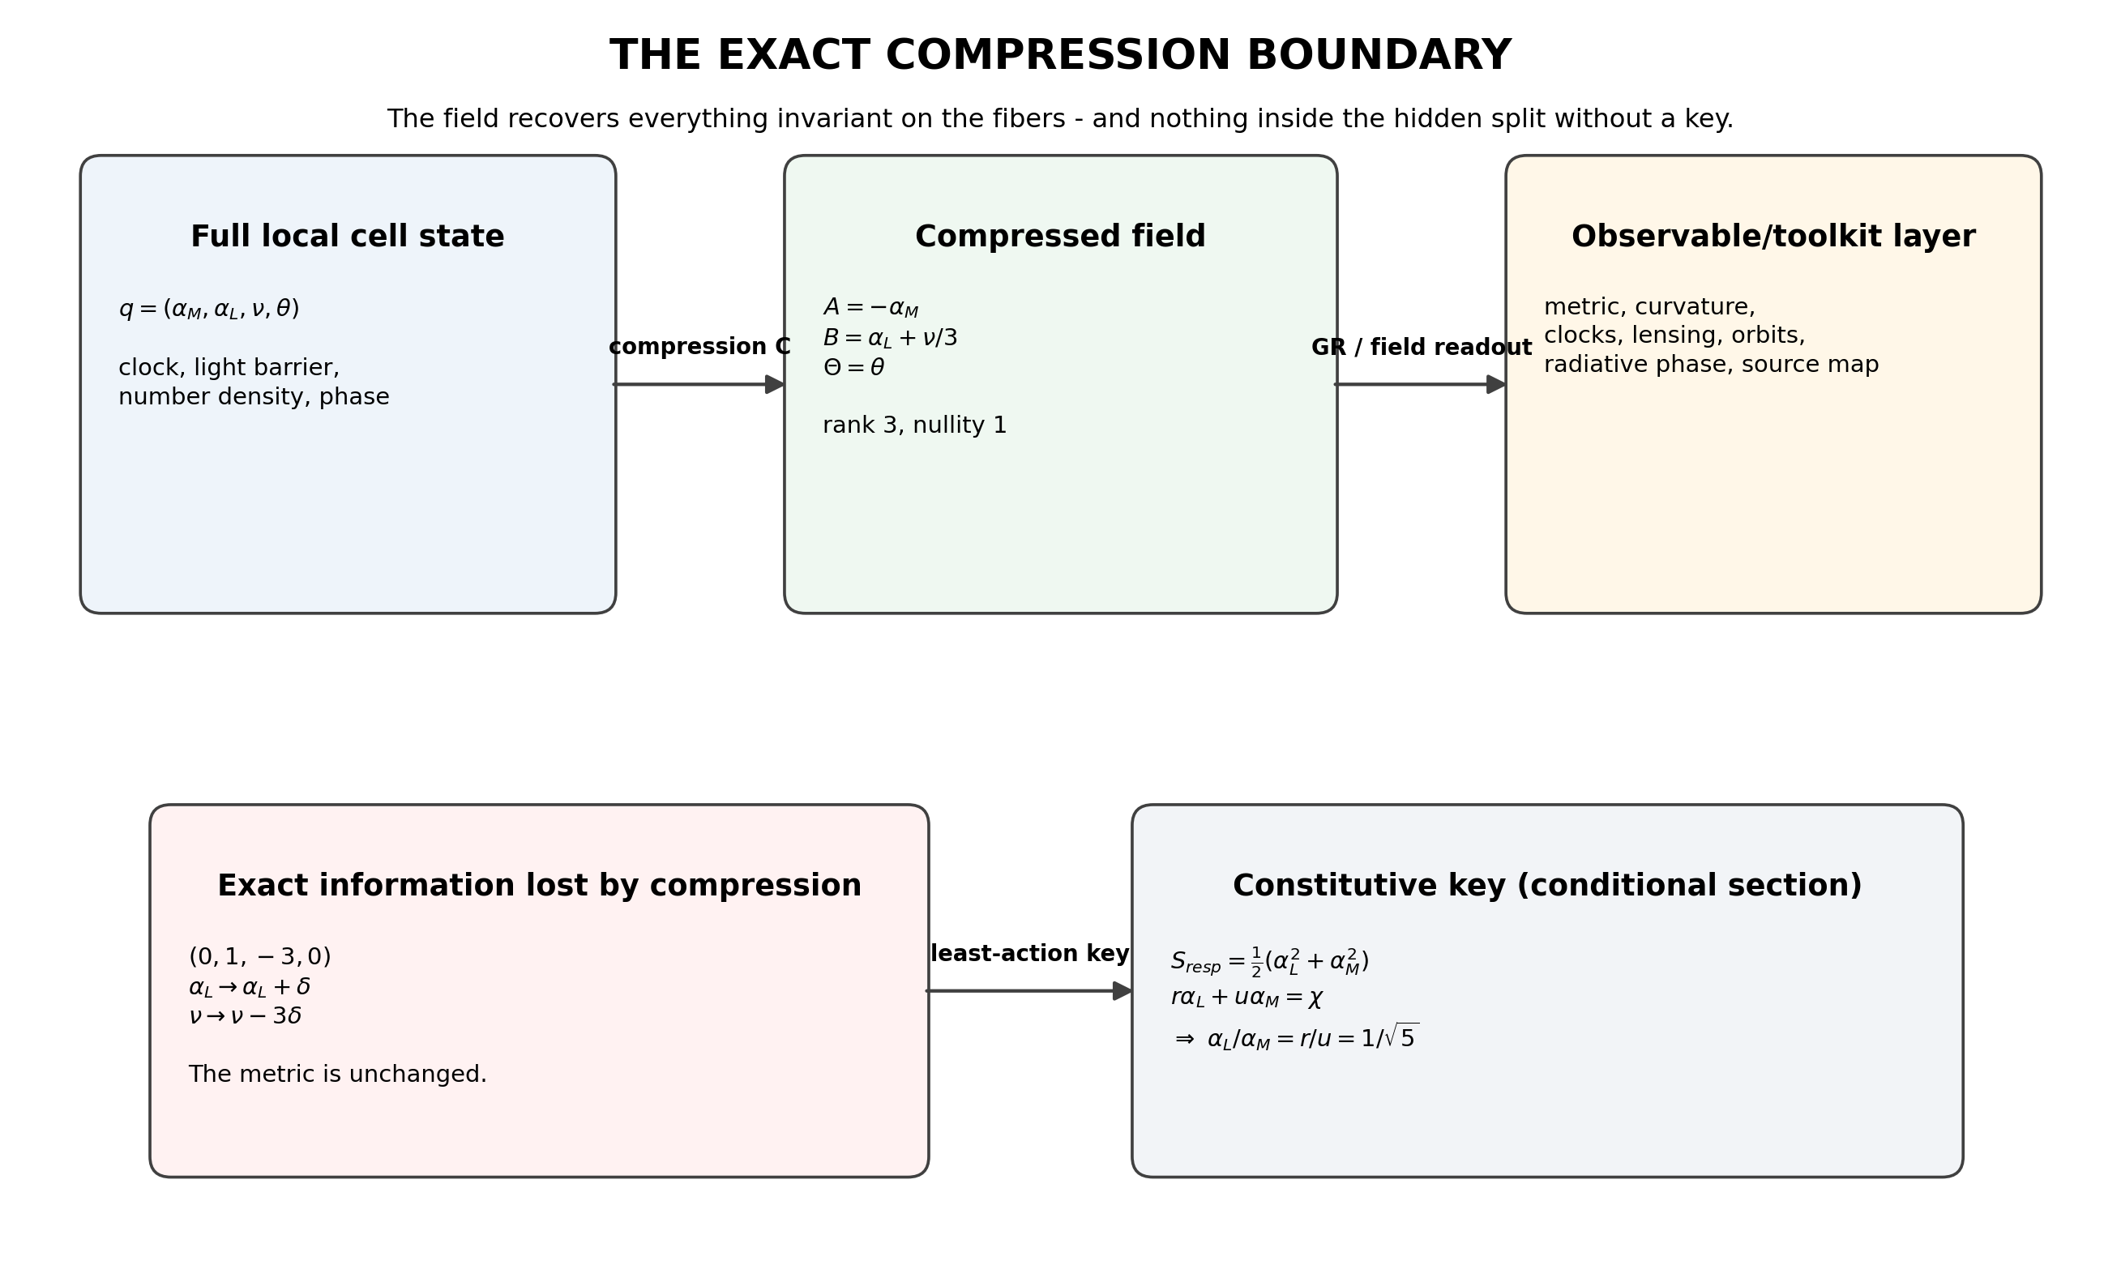
Figure 1. The exact compression boundary. The field retains three local combinations and erases one light-density split. A constitutive key selects one representative from each fiber.

1.3 Bottom-up and top-down meet at the compressed field
Bottom-up derivation and top-down observation do not have to reconstruct the same microscopic story. They have to meet on the same compressed invariants:
microphysical rules → (A,B,Θ) ← observations and established toolkits

- Bottom-up: the fixed-point algebra, cell rules and constitutive laws calculate the compressed field.
- Top-down: clocks, orbits, lensing, redshift and radiation reconstruct the same field variables.
- Validation occurs in the overlap. A unique microscopic split is not implied unless the experiment couples to the hidden direction or a constitutive law selects it.
No escape clause Compression does not excuse a failed prediction. If a quantity is a function of A, B or Θ and the field predicts it incorrectly, the claim is falsified. The threshold only prevents demands for information that the map explicitly erased.

1.4 The five gates for every future claim
Gate | Question | Failure status
Fiber gate | Is the target invariant on every compression fiber? | If no: outside current resolution.
Anchor gate | Can its physical units be built from declared measured anchors? | If no: dimensional scale remains open.
Bridge gate | Is every constitutive or representation map explicit? | If no: conditional/open bridge.
History gate | Was the expression fixed before viewing the target? | If no: postdiction or calibration.
Precision gate | Does an in-scope prediction survive the measurement uncertainty? | If no: rejected, regardless of percentage closeness.

2. Observation, calibration, and prediction are different jobs
The same measured number may enter a calculation in different roles. The paper must name the role before the calculation, because confusing an input with a prediction is the main source of false closure.
Role | Meaning | Allowed claim
Anchor | Measured quantity supplies units or a boundary condition. | Conditional dimensional result.
Calibration | Measured target fixes a matching coefficient. | Translator/model calibration, not derivation.
Validation target | Target is not used to construct the formula. | Independent test of an existing result.
Frozen forecast | A postdictive formula is locked before new data arrive. | Future evidence can support or reject it.
Two-axis grading Every statement now receives two grades. Derivational status asks whether it follows from the declared model. Evidential status asks whether it was predicted, calibrated, or chosen after seeing the observation. A formula can be a conditional theorem inside the model and still be a postdiction experimentally.

3. Source-sector closure and the constitutive key
General relativity is used as the macroscopic toolkit. The Bubble Field is the compressed decoding of the metric, not an extra minimally coupled scalar stress tensor in the exterior.
ds²=-e^{2A(ρ)}c²dt²+e^{2B(ρ)}(dρ²+ρ²dΩ²)

A=-α_M, B=α_L+ν/3

G_tt=-e^{-2B}(B′²+2B″+4B′/ρ)

G_rr=e^{-2B}(2A′B′+B′²+2(A′+B′)/ρ)

G_θθ=e^{-2B}(A′²+A″+B″+(A′+B′)/ρ)

Macroscopic result Given a relativistic energy density and pressure profile, the Einstein equations determine A and B. This completes the GR-to-bubble source dictionary in the isotropic spherical sector. It does not yet derive arbitrary matter stress-energy from microscopic cells.

3.1 Exact identifiability theorem
The metric determines α_M=-A exactly and determines only the combination α_L+ν/3=B. No metric-only experiment can identify the two pieces separately, at any precision. A nonmetric coupling or a constitutive section is required.
(α_L,ν) ~ (α_L+δ,ν-3δ)

3.2 Least-action constitutive section
The smallest explicit closure uses the mixed boundary covector (r,u) and an isotropic quadratic response cost. For a required boundary response χ, extremize
S_resp=½(α_L²+α_M²)-λ(rα_L+uα_M-χ)

Stationarity gives
α_L=λr, α_M=λu, α_L/α_M=r/u=1/√5

Status of the ratio The ratio is no longer an unexplained numerical preference. It is a conditional theorem of the declared least-cost response action. The remaining physical question is whether the microscopic boundary response is in fact measured by this Euclidean cost and mixed covector.

On the weak Schwarzschild branch B≈α_M, the density response is therefore
ν≈3(1-1/√5)α_M=1.6583592135 α_M
weak-field positive crowding

In the exact isotropic solution, use ν=3[B(α_M)-(1/√5)α_M]; the weak linear coefficient is not substituted into the strong field.

3.3 Exact exterior, interior and light bending
A=ln[(1-x)/(1+x)], B=2ln(1+x), x=GM/(2ρc²)

B(α_M)=α_M-2ln cosh(α_M/2)

The symbolic vacuum Einstein residuals vanish. The constant-density star reconstructs end to end; on the constitutive section the example with compactness 0.30 has central n/n₀=1.4766. These are exact GR reconstructions in bubble coordinates.
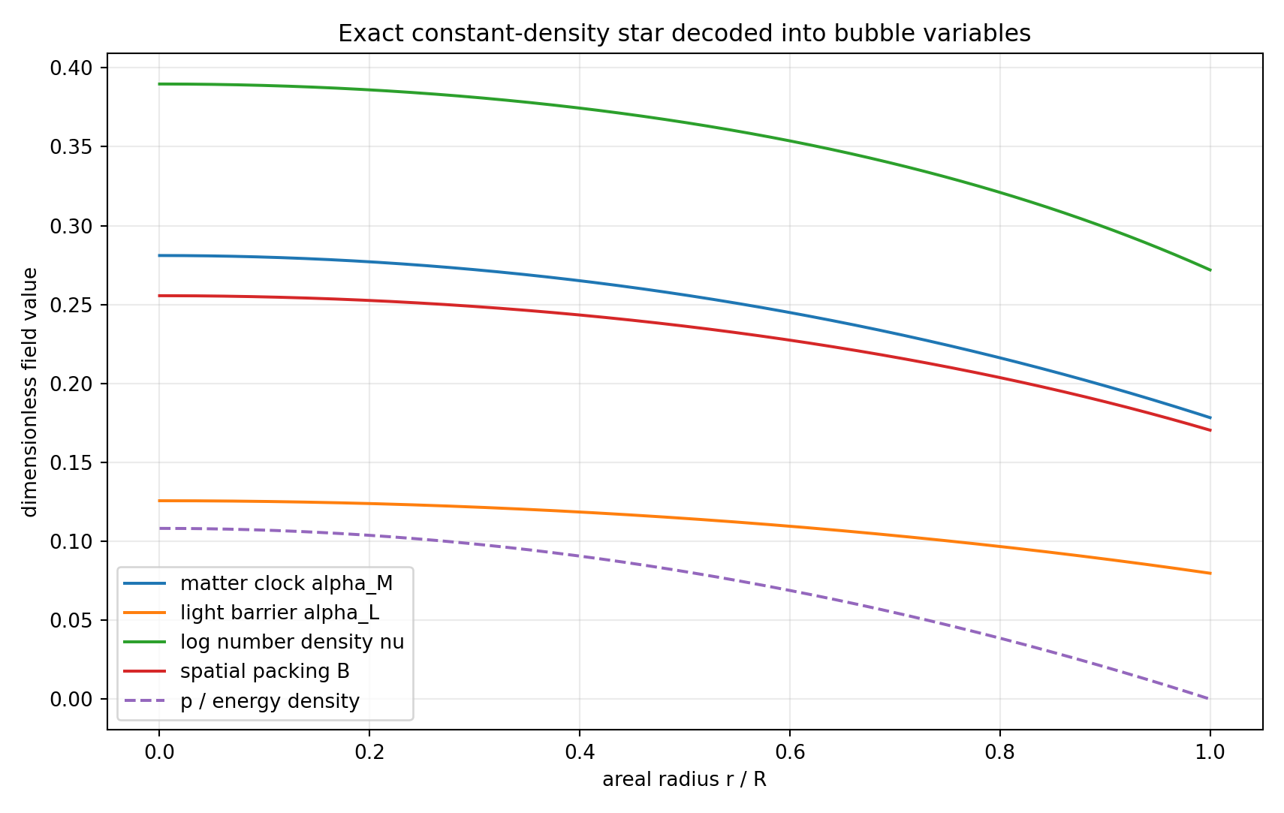
Figure 2. Constant-density relativistic star decoded into the clock, light-barrier, density and total packing variables on the least-action constitutive section.
The familiar factor of two in weak light deflection is recovered because slow motion reads the clock potential while lensing reads both clock and spatial packing. With γ=1, the spatial mode supplies the second half. This is an exact consequence of the GR dictionary, not an independent derivation of GR.

4. Cell scale, vacuum equation of state, and the dimensional boundary

4.1 The cell is an exact family, not one unqualified number
For a causal cell with ετ=ℏ, a=cτ, baseline number density n₀=a₀⁻³, and a channel fraction W carrying the observed vacuum energy density,
a₀(W)=(Wℏc/ρ_Λ)^{1/4}

Vacuum assignment | W | Cell scale
Whole cell | 1 | 87.751 µm
Matter channel | r² | 48.780 µm
The formula is the result. Choosing which channel the observed ρΛ represents is the physical branch. The paper must never quote 87.8 µm and 48.8 µm as if both were unconditional predictions of the same assignment.

4.2 Exactly when w=-1 follows
The cosmological continuity equation is
d(ρV)=-p dV

If cell renewal during expansion keeps the vacuum energy density constant, dρ=0, then
ρ dV=-p dV ⇒ p=-ρ ⇒ w=-1

Compression threshold for w Fixed action per cell does not by itself prove constant density. The result becomes exact after the cell-renewal/non-dilution rule is declared. The field can compress that rule into w=-1; it cannot infer the rule from w alone.

4.3 G and the cosmological hierarchy are one dimensionless bridge
q=Λℓ_P²/(8π)=ΛℏG/(8πc³)

a₀=√(ℓ_P L_Λ), L_Λ=√(8π/Λ)

These identities show that the Newton coupling, the vacuum hierarchy and the UV/IR cell separation encode the same missing dimensionless normalization. This is an exact reframing even before a value of q is supplied.

5. The G bridge: conditional theorem, postdictive evidence, frozen test
The registered bridge is
q_UF=r²⁴¹(1-r³)²

G_UF=[8πc³/(ℏΛ)] r²⁴¹(1-r³)²

Inside the declared representation, the factors have distinct jobs: 240 internal root modes, one external readout, and two retained legs of the emit-return interrogative cycle. If those three physical identifications hold and multiply independently, the formula follows without a continuous parameter.
Derivational grade Conditional theorem under the 240-mode factorization, external-readout and two-leg retention postulates.

Evidential grade Postdiction: the two-leg prefactor was identified after the target hierarchy was known. The expression is now frozen. Future improvement in the geometric Λ boundary is the clean test; no alternate power or retention factor may be substituted afterward.

Quantity | Value | Role
q_UF | 1.14744854e-123 | frozen model output
G_UF | 6.66438529e-11 m³ kg⁻¹ s⁻² | conditional forecast from Λ
Difference from comparison G | -0.149% | current postdictive residual
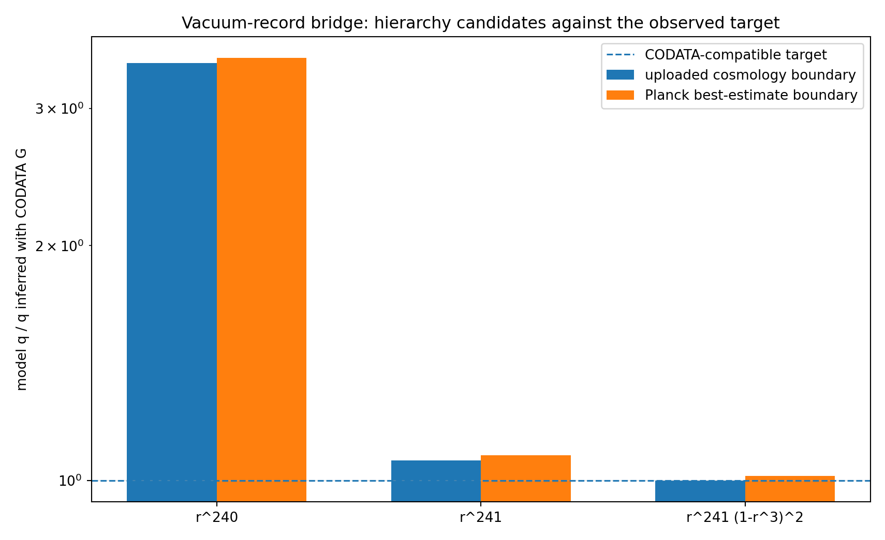
Figure 3. Discrete vacuum-record candidates. The two-leg formula is frozen as the future cosmological test branch.

6. The exact scale output and where low-energy matching begins

6.1 Structural UV/IR scale
E₀=ℏc/a₀, E_P=ℏc/ℓ_P, E_×=√(E_P E₀)

On the reproducibility branch E_×=5.2416 TeV. This is the energy form of the exact geometric-mean identity a₀=√(ℓ_P L_Λ). It is the last scale supplied by the current compression without an additional low-energy operator.

6.2 Electroweak VEV is a matching problem
v=c_EW E_×

The observed matching coefficient is c_EW=v/E_×=0.046973905. The earlier expression (r²/2)√(1-r³)=0.047036024 was chosen because it landed near v; it is not retained as a derivation.
Exact stopping point The compression produces the crossover scale E_×. A Higgs or symmetry-breaking operator must determine c_EW, the gauge couplings and the weak mixing angle. Until that operator exists, using the measured v is calibration - not a failure of the compression and not a prediction.

6.3 Charged leptons are beyond the current resolution
In the Standard Model toolkit,
M_ℓ=(v/√2)Y_ℓ

The Bubble Field currently supplies neither the Yukawa operator Yℓ nor an eigenvalue theorem forcing generation depths. Therefore exact electron, muon and tau masses vary inside unresolved spectral detail and do not pass the Fiber/Bridge gates.
Withdrawal The previous formulas m_e=vr¹¹(1-r/2), m_μ=m_eφ¹¹(1+r³), and m_τ=m_eφ¹⁷(1-r³) are removed from the active theory. Their sub-percent proximity is not enough at the precision of lepton data. They remain only as a documented rejected ansatz.

A future lepton claim enters scope only after the theory constructs a localized phase/winding operator, proves its spectrum and fixes the dimensional matching without using the lepton masses as targets.

7. Translators, no-go results, and operator-dependent outputs

7.1 QCD tension is a translator identity
σ=ρa²=E/a=E²/(ℏc), a=ℏc/E

Supplying σ and recovering E is algebraic inversion. The field has not selected the QCD scale. The vacuum-cell identification remains excluded by roughly 10²³ in the existing audit.

7.2 Dark matter: distinguish energy from geometry
The literal claim that vacuum-cell crowding energy supplies the missing galactic dark-matter energy density is excluded by roughly eleven orders. That no-go does not automatically exclude a relational or geometric crowding interpretation, because metric reconstruction and extra material energy are different observables. Any revived dark-sector claim must state which one it means.

7.3 Range hierarchy begins at the operator assignment
Mode | Declared operator | Green function | Status
Light | -∇² | 1/r | infinite after massless kinetic assignment
Boundary | -∇²+m_B² | e^{-m_Br}/r | finite after massive kinetic assignment
Matter | m_M² without spatial kinetic term | local algebraic response | zero/contact after auxiliary assignment
The ranges follow exactly from these operators. The three channel weights and block counts alone do not uniquely force the operators, so the range hierarchy remains a conditional representation result.

8. The field recovery threshold - final statement
The Universal Field of Least Action is neither required nor permitted to claim unlimited bottom-up reconstruction. Its formal scope is the set of observables that factor through its compression map, plus quantities obtained after explicitly declared anchors and constitutive sections.
Recoverable set R_C={Q | Q=Q̃∘C}

Conditional set R_{C,s}={Q | Q=Q̃∘s∘C for a declared section s}

Outside set O_C={Q | Q changes along ker(DC) and no extra channel is supplied}

Operational threshold At the present scalar-phase level, the field gets A, B and Θ and every invariant made from them. It gets α_M from A. It does not get α_L and ν separately without the constitutive key. It gets the structural UV/IR scale, but not low-energy spectral eigenvalues without a matching operator. That is the exact point at which the inference stops.

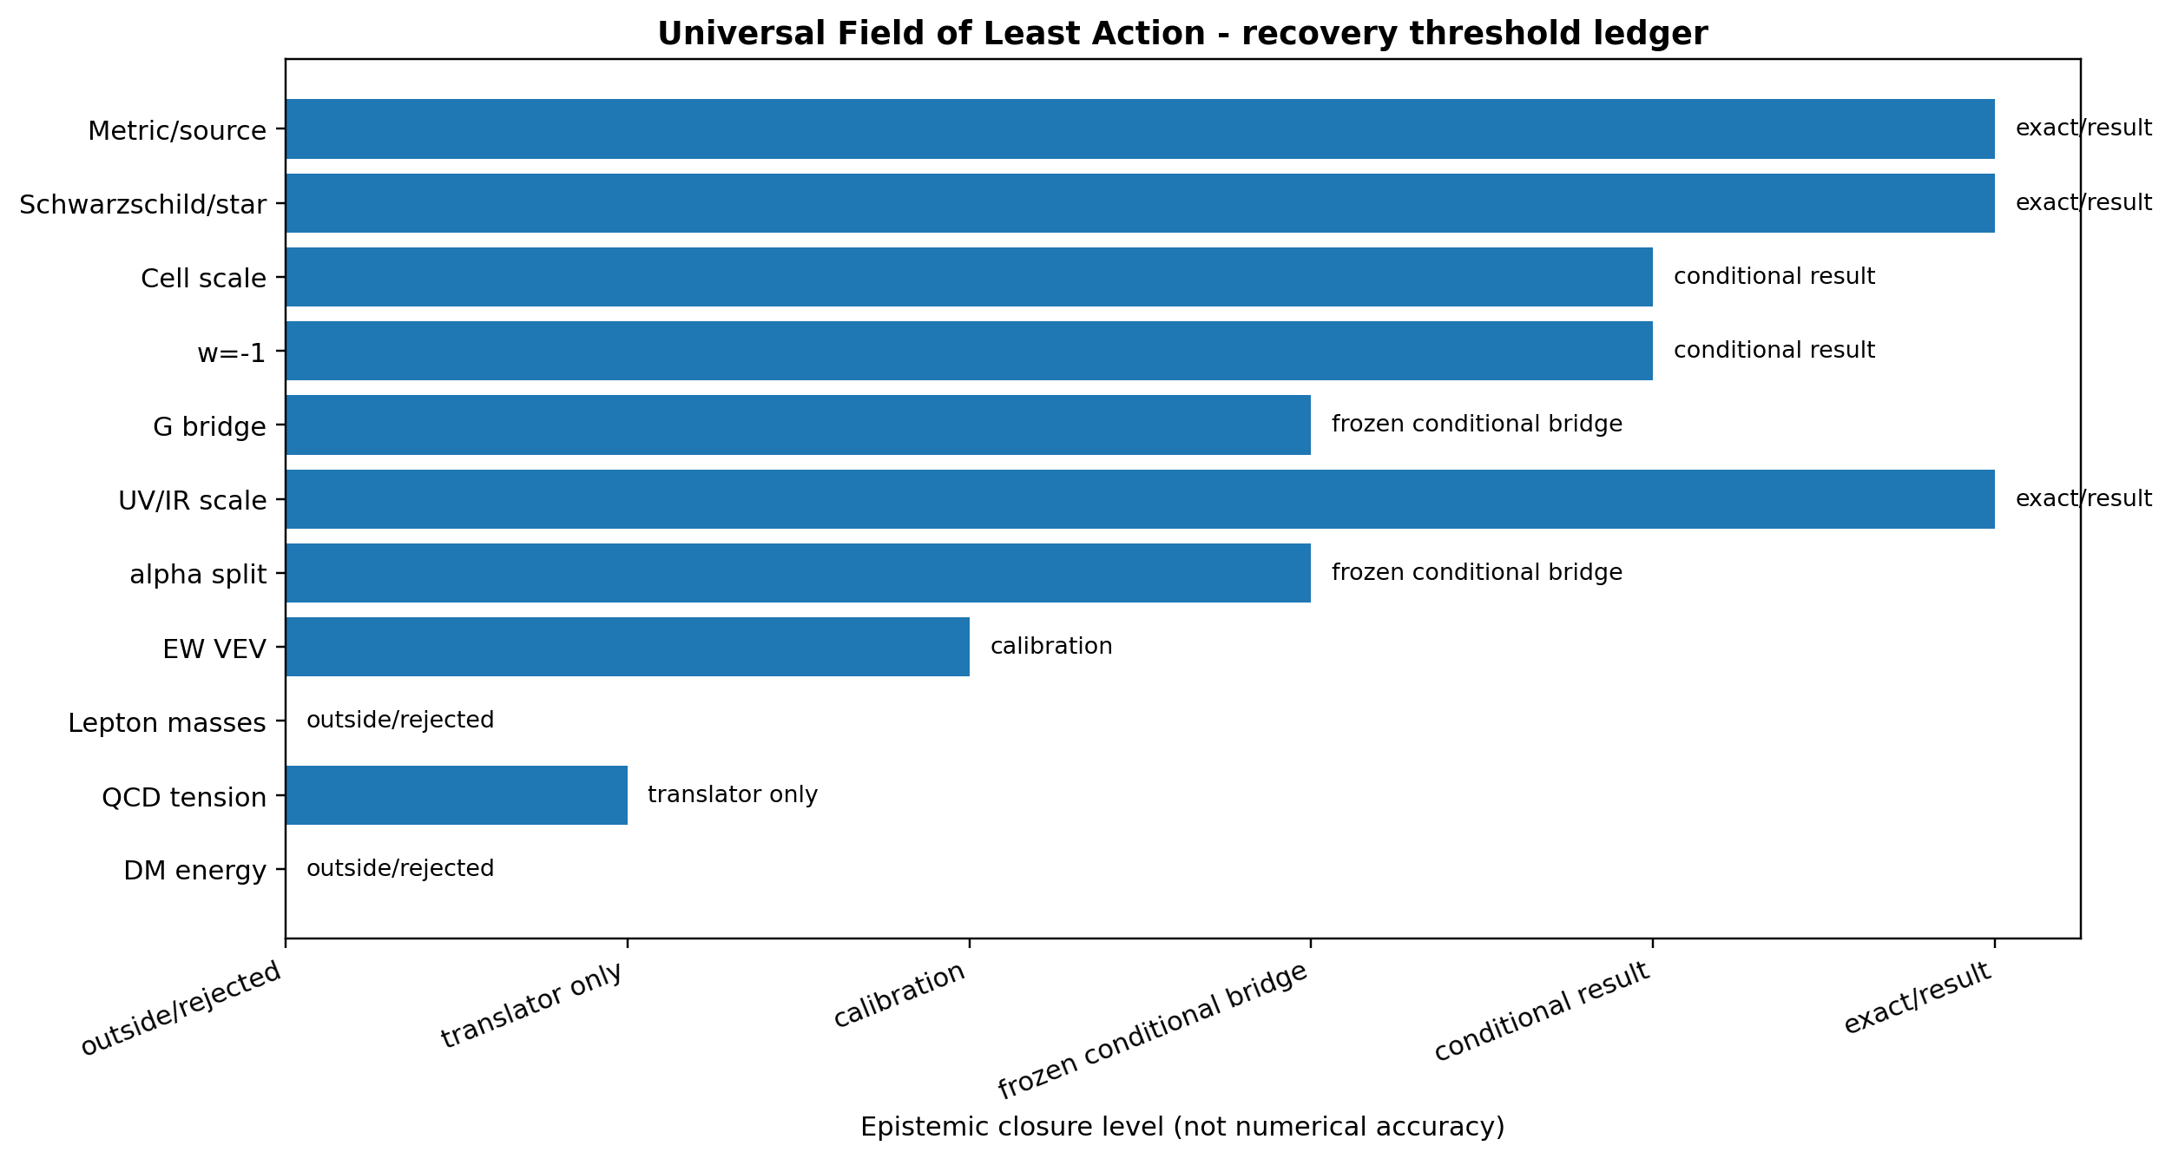
Figure 4. Final recovery ledger. The horizontal position describes derivational closure, not numerical closeness.

8.1 The claim-writing protocol
- Write the compression map and its kernel for the sector being studied.
- Name all measured quantities as anchors, calibrations, validation targets or frozen forecasts.
- Test fiber invariance before attempting a numerical formula.
- Add a constitutive section only through an explicit action or response law.
- Do not label a translator identity as a prediction.
- Reject an in-scope precision formula when it misses, even if its percentage error appears small.
- Do not call an out-of-scope microscopic detail a failure of the compressed field; call it an operator still absent from the representation.

8.2 What is closed now
- The local information budget: rank three, nullity one.
- The exact metric/source dictionary in the isotropic spherical sector.
- The exact reason gravity cannot identify the light-density split.
- A smallest conditional least-action section giving α_L/α_M=1/√5.
- The exact cell-scale family and conditional w=-1 theorem.
- The exact G/Λ hierarchy identity and one frozen conditional G bridge.
- The exact UV/IR crossover scale and the precise point where electroweak matching begins.
- The withdrawal of the charged-lepton ansatz and QCD “prediction” language.
- The exclusion of vacuum crowding energy as galactic dark matter.

8.3 What remains genuinely physical
- Derive the 240-mode vacuum projector and external readout as a physical stress-energy observable, rather than a representation postulate.
- Derive or falsify the Euclidean mixed-boundary response action microscopically.
- Extend the compression map beyond the spherical scalar sector to shear, rotation and general tensor geometry.
- Construct the symmetry-breaking and mass operators that map E_× to Standard Model couplings and spectra.
- Derive an observable short-distance transfer function for the cell scale; a length by itself is not a laboratory signal.

Appendix A. Reproducibility certificate
The accompanying compression-boundary script symbolically calculates the compression rank and kernel, tests representative recoverability directions, derives the least-action constitutive ratio, freezes the G bridge, calculates the scale-matching boundary, and writes the final claim ledger.
File | Role
bubble_field_compression_boundary.py | compression theorem, constitutive derivation and status audit
bubble_field_compression_boundary_results.json | machine-readable certificate
bubble_field_compression_boundary_map.png | exact compression diagram
bubble_field_recovery_ledger.png | claim-threshold visualization
bubble_field_closure_attack.py | source equations, star reconstruction and G calculation
bubble_field_closure_attack_results.json | prior numerical certificate, regraded here

Appendix B. Status vocabulary
Term | Meaning
Exact result | Follows from the declared equations and lies inside the compressed output space.
Exact representation | An established toolkit solution is reconstructed without residual in the field variables; this is not automatically a microscopic derivation of the toolkit.
Conditional theorem | Follows exactly after named physical postulates or a constitutive section are admitted.
Calibration | An observed target fixes a matching coefficient.
Frozen forecast | A postdictive formula is locked and exposed to genuinely new data.
Translator | An identity converts one supplied physical quantity into another supplied scale.
Outside resolution | The target varies along a compression kernel or requires an absent operator.
Rejected | A declared in-scope formula fails empirical precision or a structural no-go.

Appendix C. Source lineage
- Shields, J. The Bubble Field: Gravity as overcrowding in a sea of least-action cells. Working paper, 29 July 2026.
- Shields, J. Least-Cost Holonomy and Co-Distinction Fields. Working paper, July 2026.
- Shields, J. Unified Mechanics bridge-closure corpus. Golden partition, traversal floor, conditional E8 vacuum projector and external readout.
- Exact toolkit solutions: isotropic Schwarzschild exterior and constant-density Schwarzschild interior.
- Planck 2018 cosmological boundary and 2022 CODATA comparison values as recorded in the prior reproducibility package.
END OF COMPRESSION BOUNDARY CLOSURE

